**Jenkins master slave configuration**

**Module-1:**

* Create and run a two EC2 Linux instance in AWS

**Step to create a new two EC2 instance:**

* In AWS console click on services -> EC2
* Click on Launch instance
* Choose Amazon Machine Image (AMI)

***Amazon Linux 2***

* Select instance type

***t2.micro***

* Select key pair
* In network settings select VPC, Subnets
* Select Security group

***SSH = 22***

***HTTPD = 80***

***HTTPS = 443***

* Configure storage

***Give 16 GB storage***

* Give number of servers 2
* Create it.

**Module-2: how to setup a Jenkins build server on AWS EC2**

* Connect two instances with SSH

**Step to download and install Jenkins into two instances:**

* Run the following command to update the machine

***Sudo yum update***

* Install the Java version 11 into machine

***sudo yum -y install java-11\****

* Install the require Jenkins repos

***sudo wget -O /etc/yum.repos.d/jenkins.repo*** [***https://pkg.jenkins.io/redhat-stable/jenkins.repo***](https://pkg.jenkins.io/redhat-stable/jenkins.repo)

***sudo rpm --import https://pkg.jenkins.io/redhat-stable/jenkins.io.key***

* Install the Jenkins

***sudo yum -y install jenkins***

* Start and Enable the Jenkins

***sudo systemctl start jenkins***

***sudo systemctl enable jenkins***

* Copy the public IP of master instance

***Public IP :8080***

* Copy the password path from Jenkins page

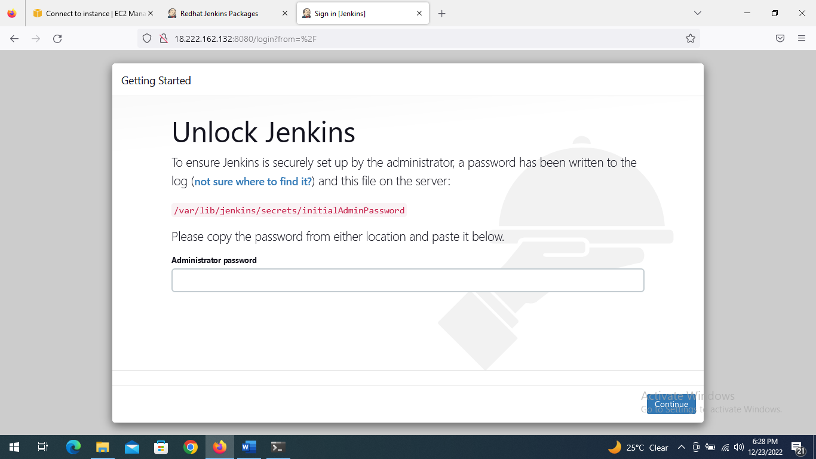

* Paste the path into terminal

***[ec2-user@ip-10-0-0-96 ~]$ sudo cat /var/lib/jenkins/secrets/initialAdminPassword***

* Get a password and copy it and paste it in Jenkins page
* Select Install suggested plugins
* Give some credentials and continue
* Open jenkins welcome page

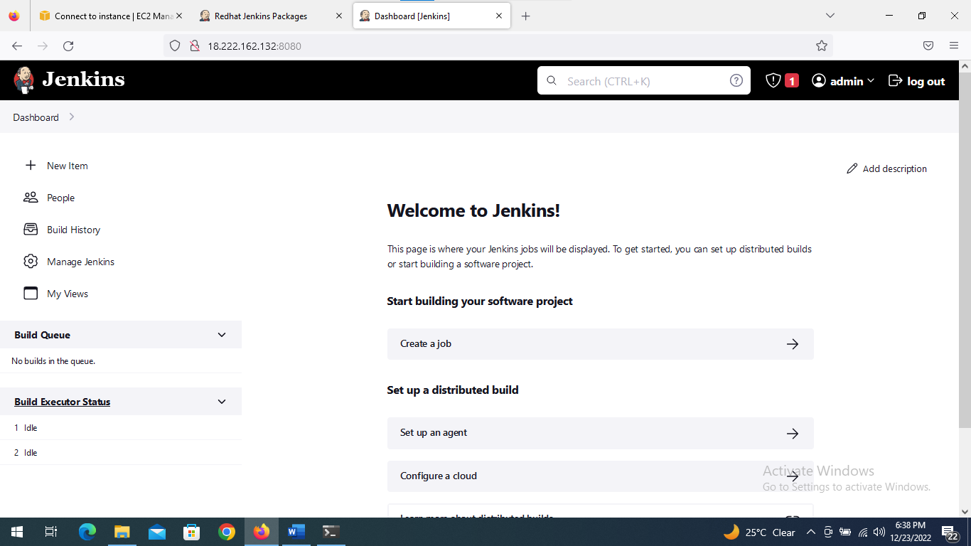

**Module-3:**

**Configure jenkins slave node:**

* In slave node terminal tab
* Add new user

***[ec2-user@ip-10-0-0-227 ~]$ sudo useradd jenkins-slave1***

***[ec2-user@ip-10-0-0-227 ~]$ sudo su - jenkins-slave1***

***[jenkins-slave1@ip-10-0-0-227 ~]$***

* Generate the key

***[jenkins-slave1@ip-10-0-0-227 ~]$ ssh-keygen -t rsa -N "" -f /home/jenkins-slave1/.ssh/id_rsa***

* Change directory

***[jenkins-slave1@ip-10-0-0-227 ~]$ cd .ssh/***

* Add content of id_rsa into authorized_keys

***[jenkins-slave1@ip-10-0-0-227 .ssh]$ cat id_rsa.pub>authorized_keys***

* Change the permission of authorized_keys

***[jenkins-slave1@ip-10-0-0-227 .ssh]$ chmod 700 authorized_keys***

**Configure Jenkins master slave :**

* Create a directory

***[ec2-user@ip-10-0-0-96 ~]$ sudo mkdir -p /var/lib/jenkins/.ssh***

* Change the directory

***[ec2-user@ip-10-0-0-96 ~]$ cd /var/lib/jenkins/***

* Give read ,write and execute permissions for created directory

***[ec2-user@ip-10-0-0-96 jenkins]$ sudo chmod 777 .ssh/***

* Change directory

***[ec2-user@ip-10-0-0-96 jenkins]$ cd .ssh/***

* Copy the private IP of slave1 into master slave

***[ec2-user@ip-10-0-0-96 .ssh]$ sudo ssh-keyscan -H 10.0.0.227>>/var/lib/jenkins/.ssh/known_hosts***

# 10.0.0.227:22 SSH-2.0-OpenSSH_7.4

# 10.0.0.227:22 SSH-2.0-OpenSSH_7.4

# 10.0.0.227:22 SSH-2.0-OpenSSH_7.4

* Change owner permissions

***[ec2-user@ip-10-0-0-96 .ssh]$ sudo chown jenkins:jenkins known_hosts***

* Give permissions for known_hosts

***[ec2-user@ip-10-0-0-96 .ssh]$ sudo chmod 700 known_hosts***

* Click on the manage Jenkins

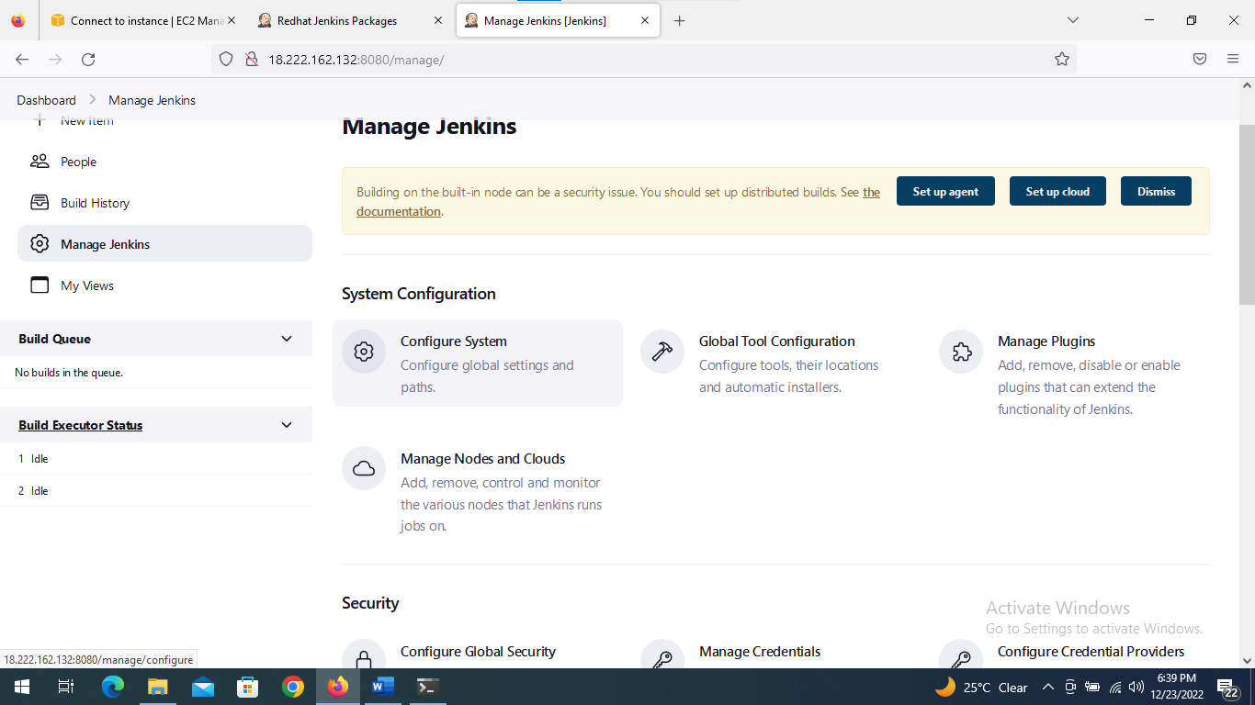

* Click on the manage node and clouds

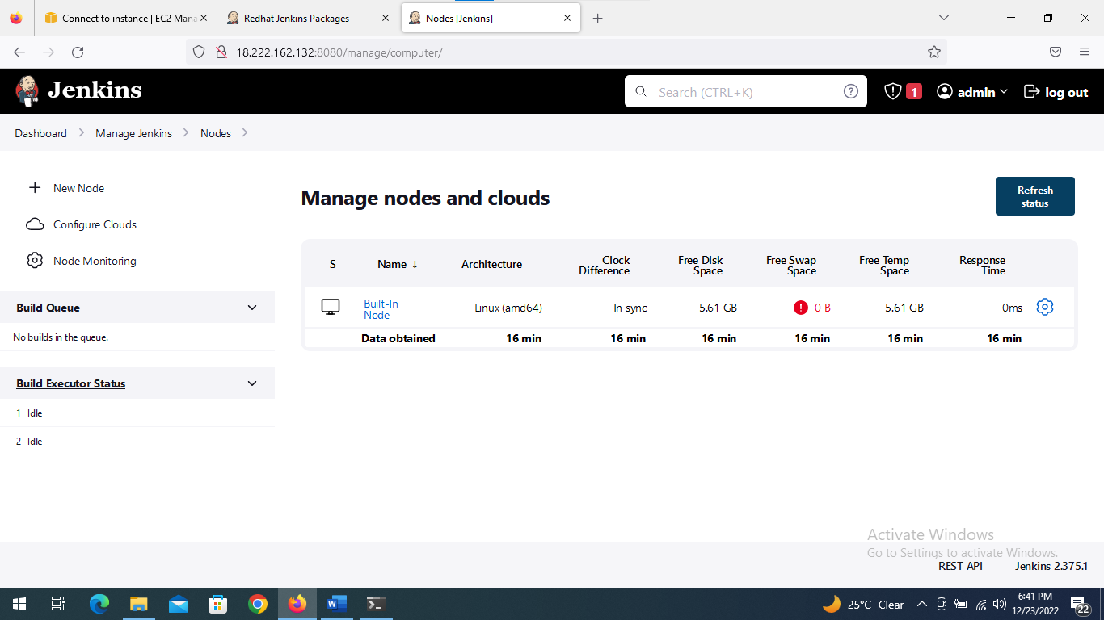

* Click on new node

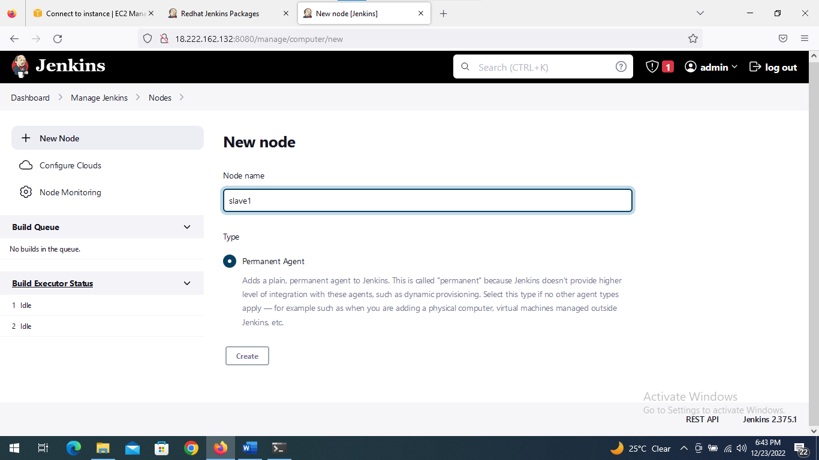

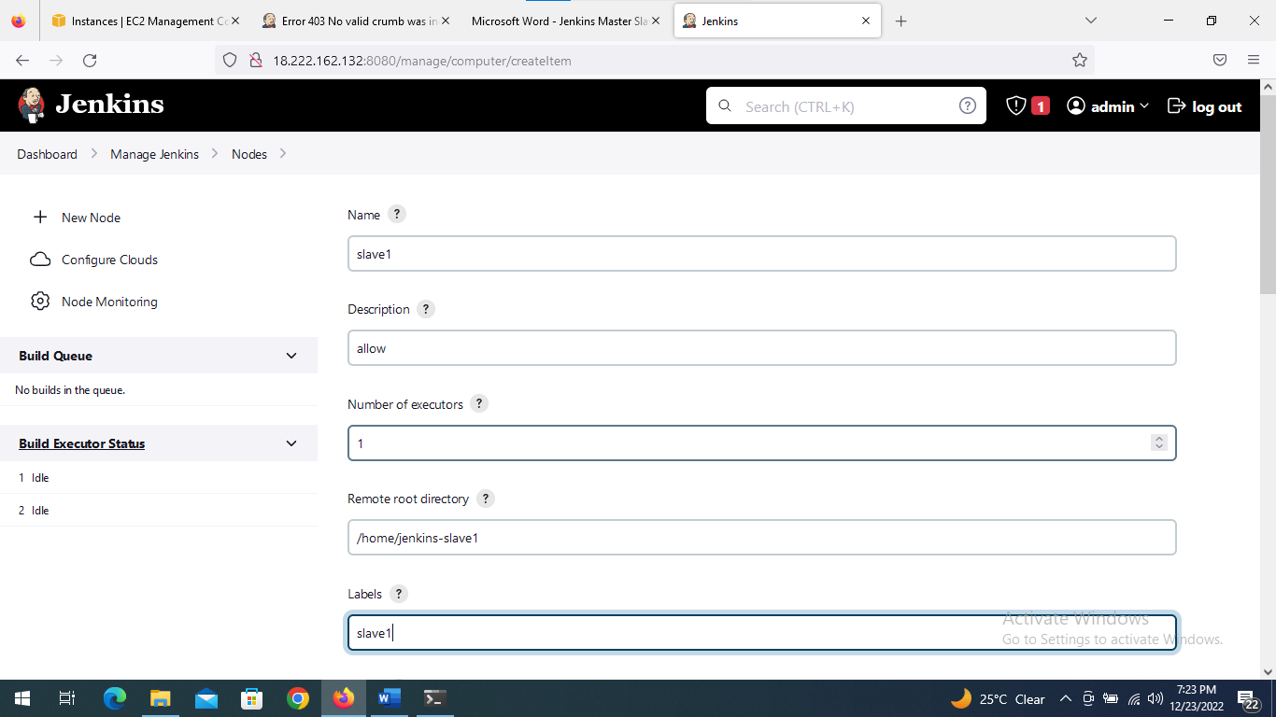

* Create credentials by using ssh private key

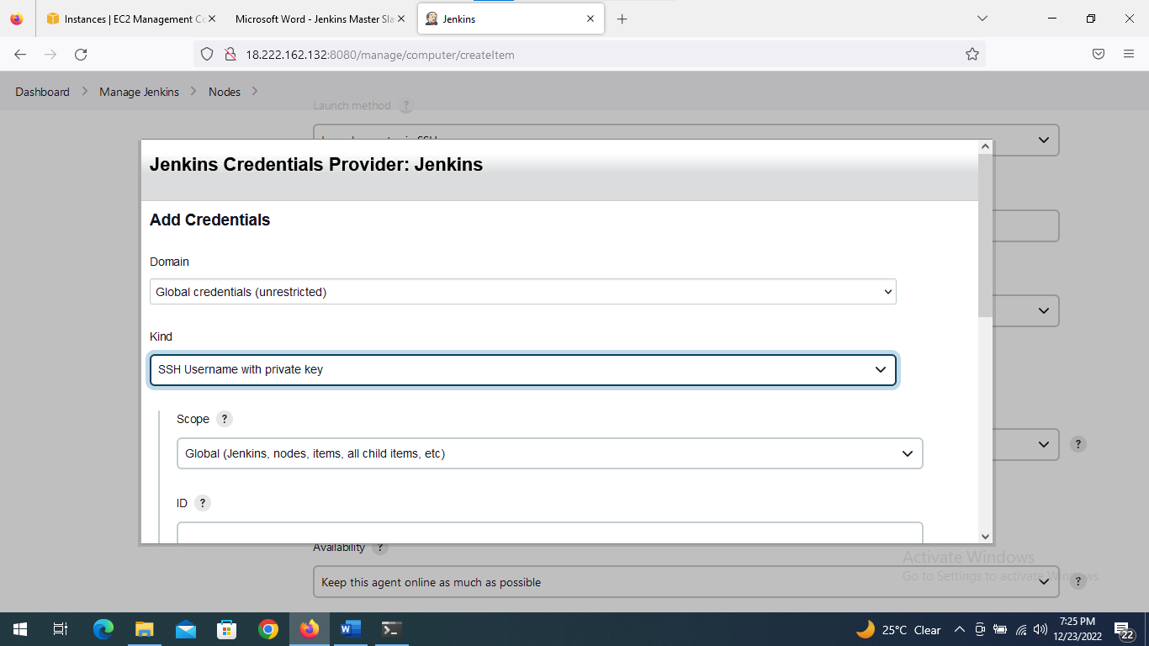

* For getting private key using this below command in slave node

***[ec2-user@ip-10-0-0-227 ~]$ sudo su - jenkins-slave1***

***[jenkins-slave1@ip-10-0-0-227 ~]$ cd .ssh/***

***[jenkins-slave1@ip-10-0-0-227 .ssh]$ more id_rsa***

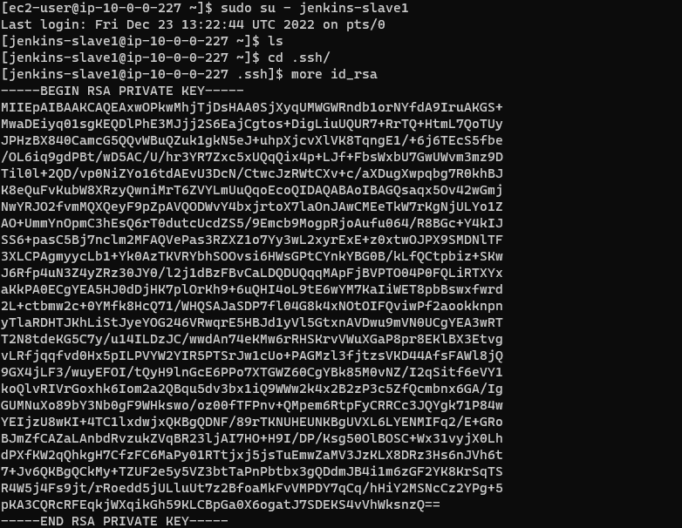

* Copy the private key paste it into creating credentials page and add it

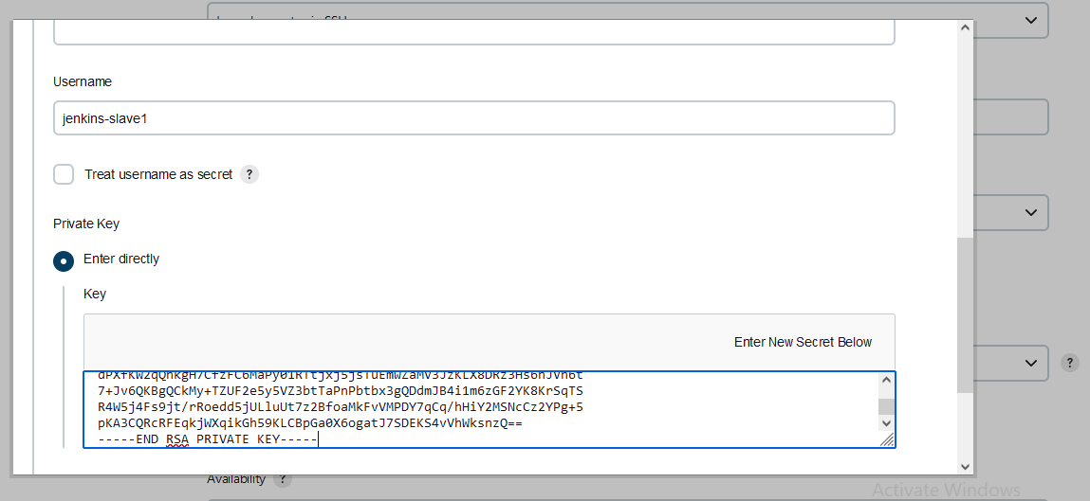

* Choose credentials

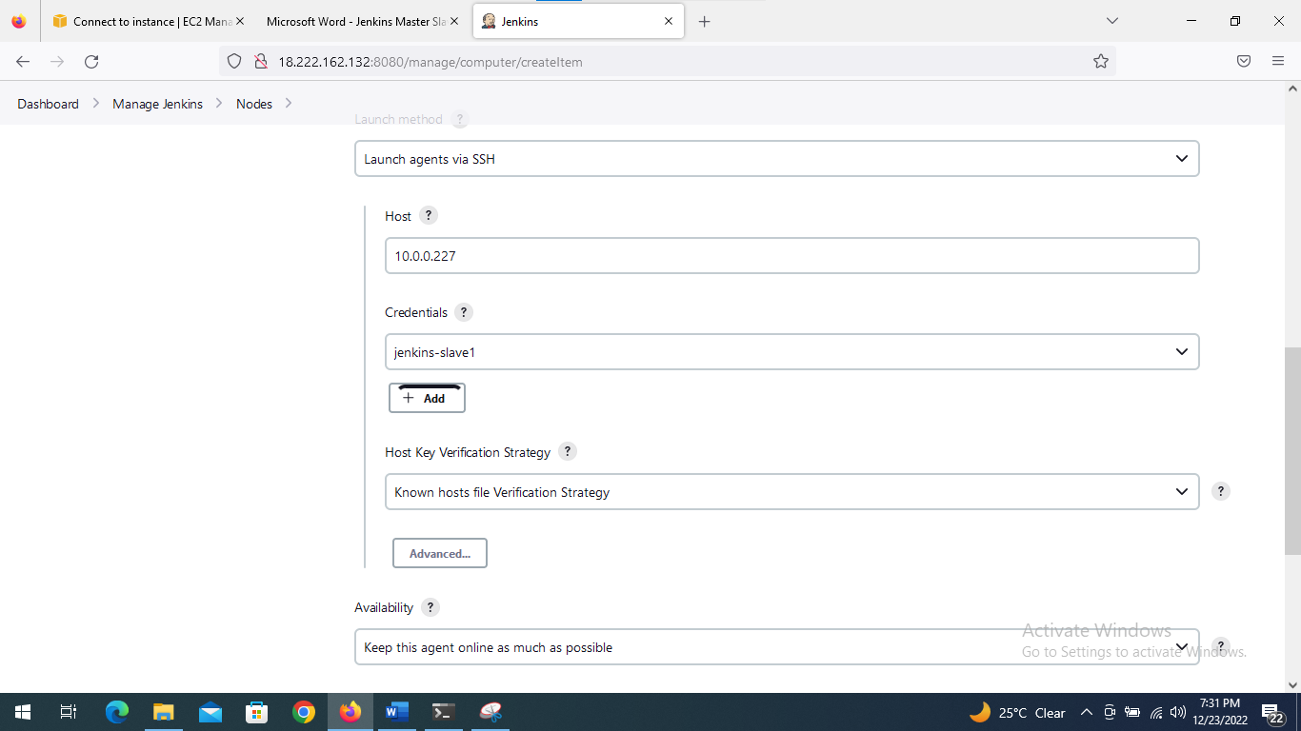

* Save it and click on logs
* It shows success and online

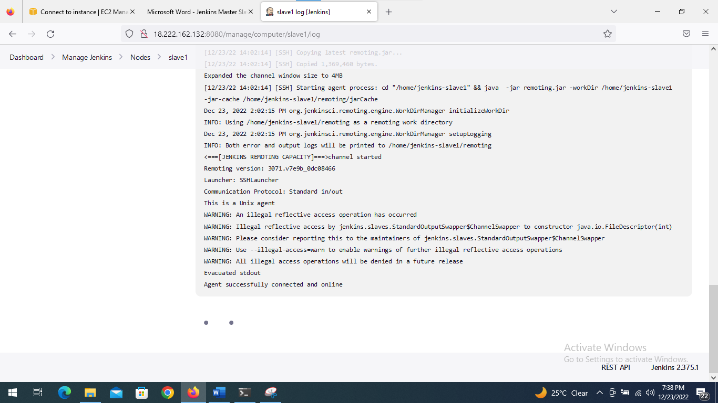

* Create second slave instance and connect with ssh
* Install jenkins in slave2

**Configure jenkins slave node 2:**

* Click on the manage Jenkins



* Click on the manage node and clouds



* Click on new node

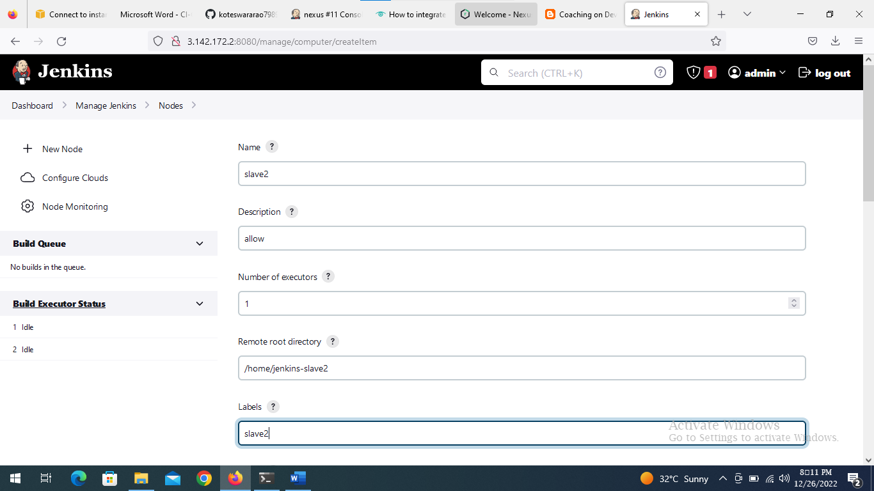

* Create credentials by using ssh private key
* For getting private key using this below command in slave node

***[ec2-user@ip-10-0-0-227 ~]$ sudo su - jenkins-slave2***

***[jenkins-slave1@ip-10-0-0-227 ~]$ cd .ssh/***

***[jenkins-slave1@ip-10-0-0-227 .ssh]$ more id_rsa***



* Copy the private key paste it into creating credentials page and add it

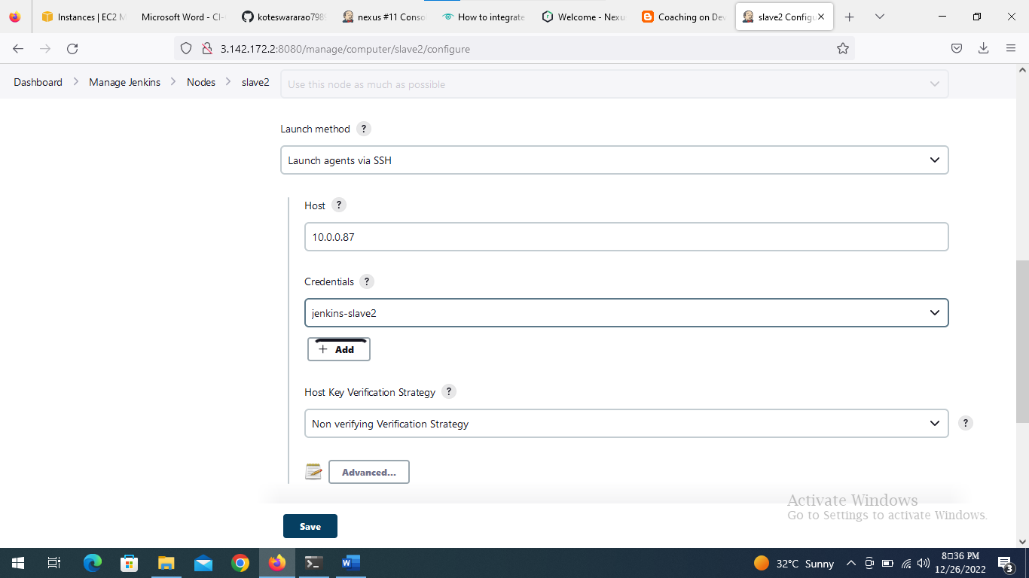

* Choose credentials

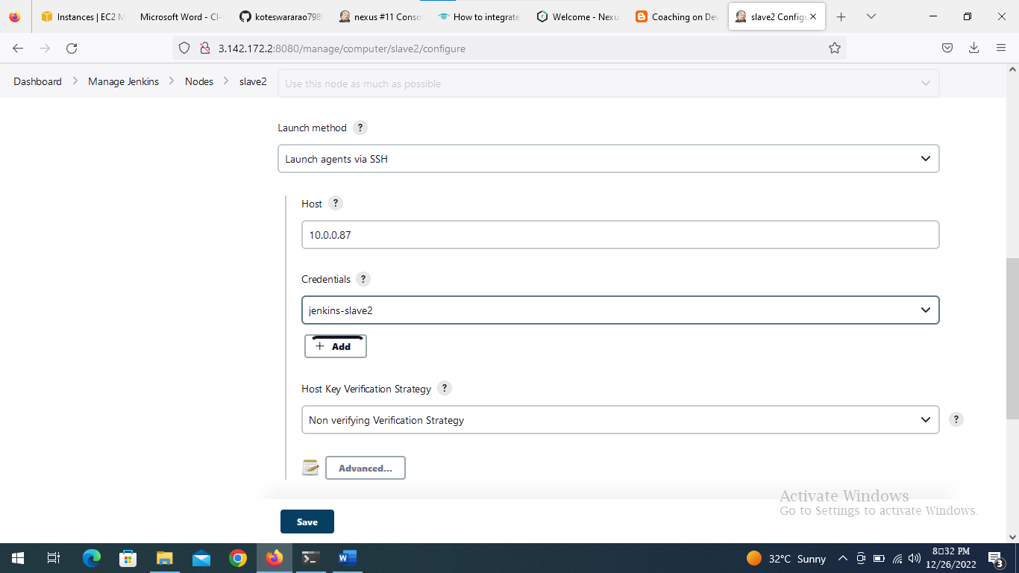

* Save it and click on logs
* It shows success and online

